Huisje 1: The Cloud Cottage ☁️🏡

**Home Assistant URL**: the-cloud-cottage.local:8123  
**Login:** pi / home  
**Wifi**: Itenium2025 / DenBerg1840! (Gateway: 172.16.10.254, Subnet: 255.255.25**2**.0)

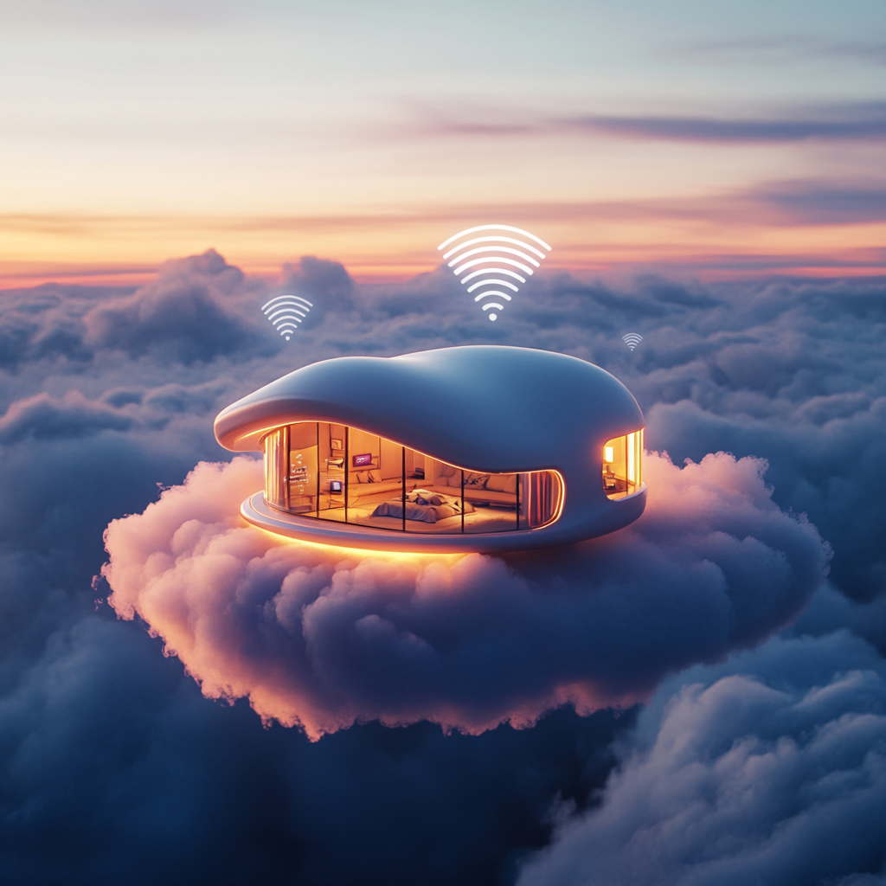

Huisje 2: Casa del Lag 🏠💨

**Home Assistant URL**: casa-del-lag.local:8123  
**Login:** pi / home

**Wifi**: Itenium2025 / DenBerg1840! (Gateway: 172.16.10.254, Subnet: 255.255.25**2**.0)

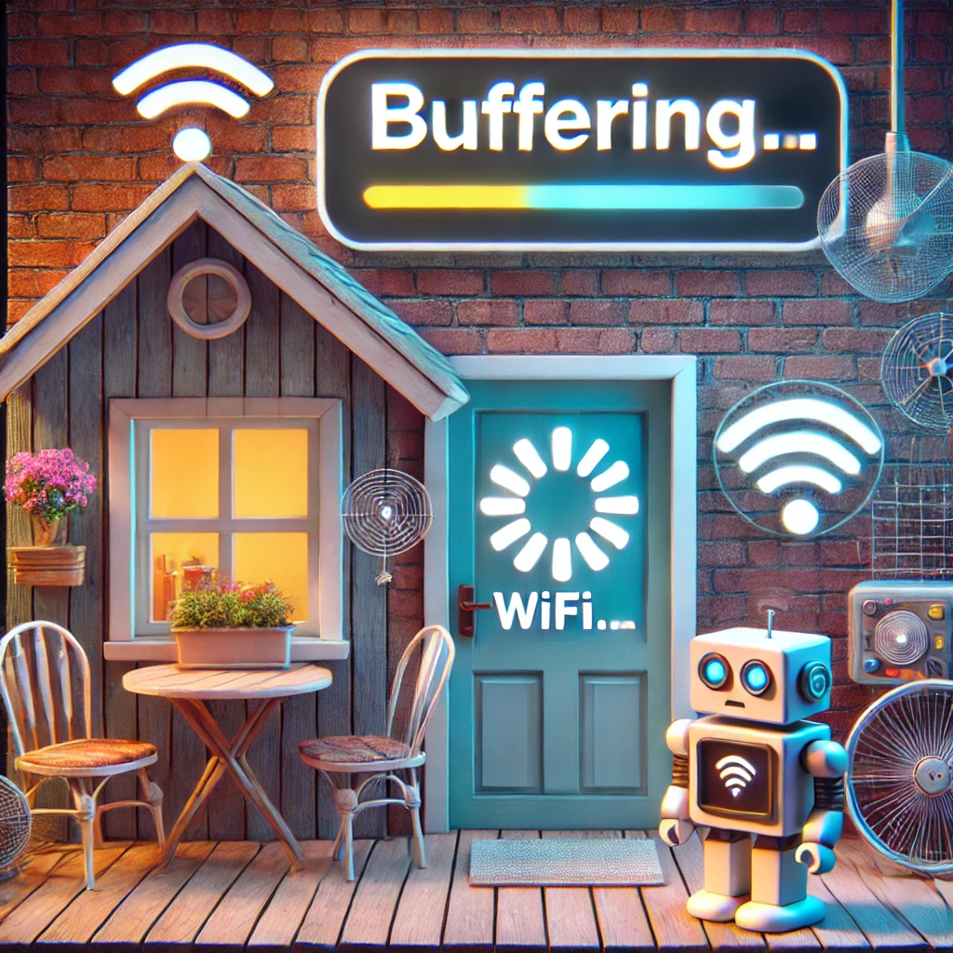

Raspberry: The Reboot Ranch 🔄🐴

**Home Assistant URL**: the-reboot-ranch.local:8123  
**Login:** pi / home **Wifi**: Itenium2025 / DenBerg1840! (Gateway: 172.16.10.254, Subnet: 255.255.25**2**.0)

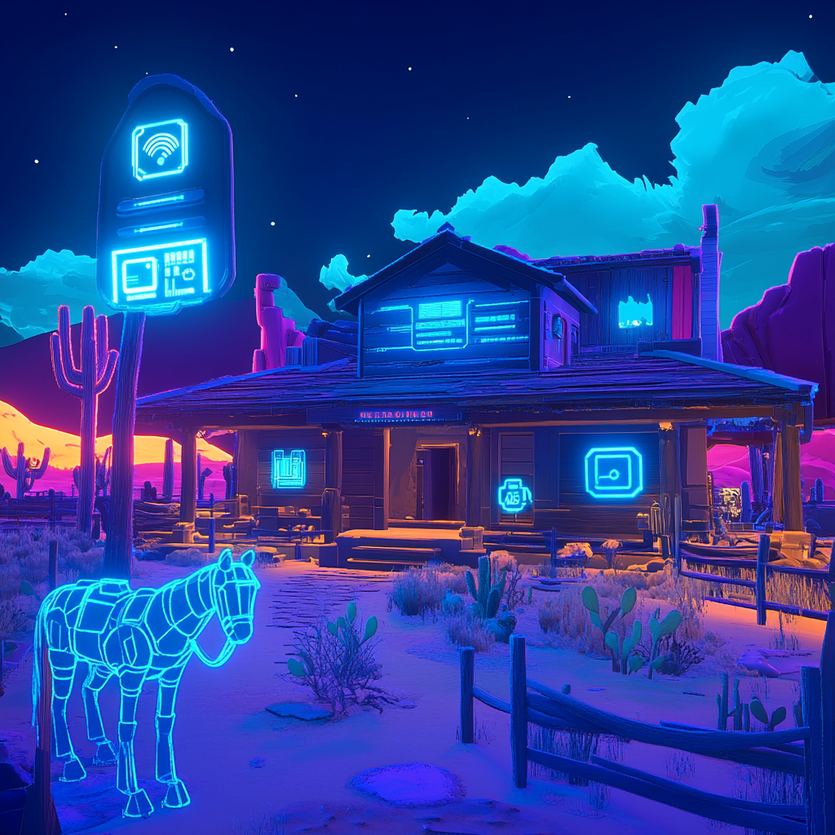

Huisje 4  
The Overengineered Hut 🏡🤖

**Home Assistant URL**: the-overengineered-hut:8123  
**Login:** pi / home **Wifi**: Itenium2025 / DenBerg1840! (Gateway: 172.16.10.254, Subnet: 255.255.25**2**.0)

